1. From teach pendent press **Select,** then select the program **JR-CALICRATION,** press enter.

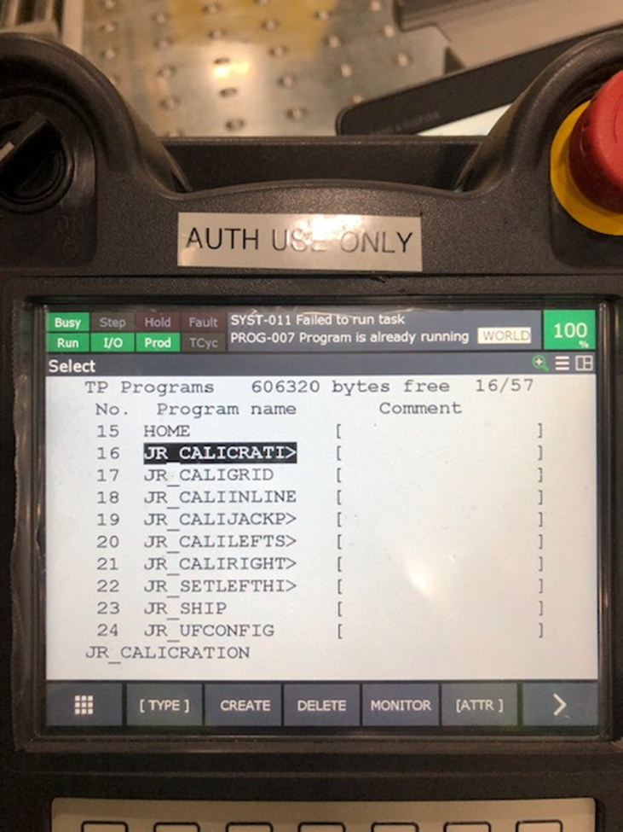

1. Press the **step** button the teach pendent. *The Step icon in the top left corner will turn amber*.

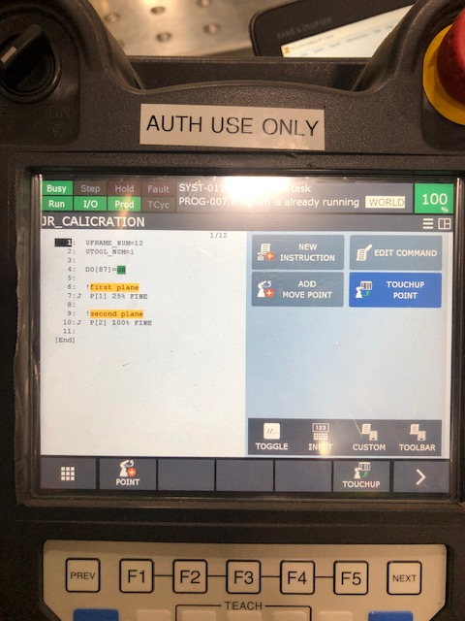

1. While holding the blue **shift button**, and both **dead man switches** on the back of the teach pendant, push and release **FWD**.

The program will step to the next line every time the FWD button is pushed. There will be a @ symbol beside the step you are on.

A prompt may appear saying that there is another program running. If so press the **FCTN** button and then press enter on the defaulted first option **ABORT ALL**

1. Step though the program until the @sign is beside line **7 P (1) 25% Fine**.

The robot should be positioned over the grid beside the infeed conveyor with camera lights on.

1. After the robot has been moved to step 7, press **menu** and scroll down to **8 IRVISION**. Select **Vision setup** from the submenu then enter.

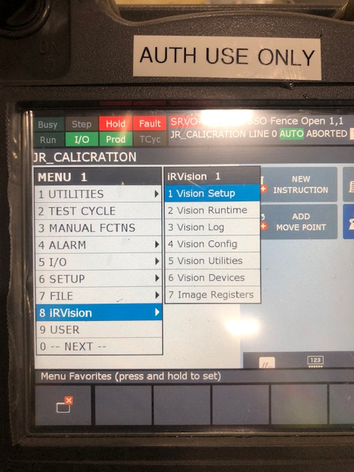

1. From the vision set up screen press the right arrow moving from #1 camera set up, to #2 calibration, then enter.

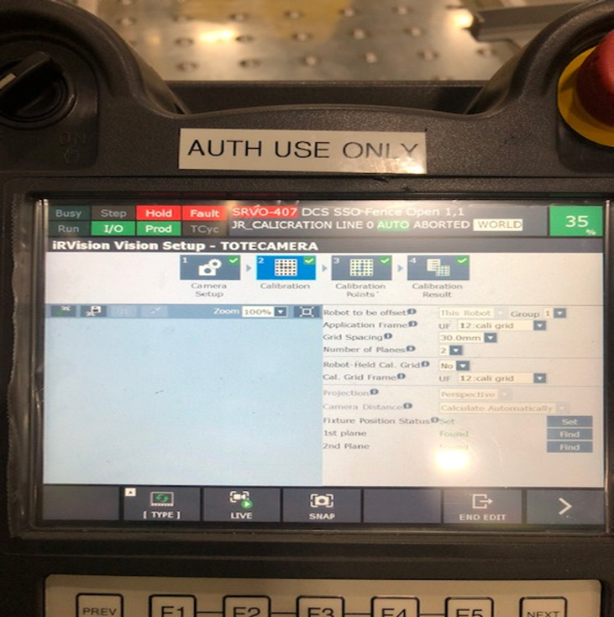

1. Press F3 for Snap
2. Press the **1st Plane** **Find** button on the screen



There will be a prompt saying that there was a problem, disregard and move on.

1. Press the **EDIT** button. This will take you back to the **JR Calcration** program
2. While holding the blue **shift button**, and both **dead man switches** on the back of the teach pendant in, **push FWD** until the @ sign id beside step 10 **P (2) 100% fine**



1. After the robot has been moved to step 10, press **menu** and scroll down to **8 IRVISION**. Select **Vision setup** from the submenu then enter.

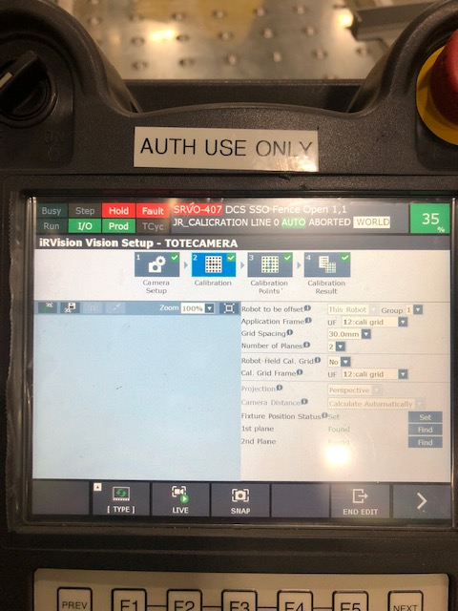

1. Press **F3** for snap, Then 2nd Plane **Find**

There will be a prompt saying that there was a problem, disregard and move on.

**The calibration is not complete until it is saved and the edit is ended.**

1. Press **Next** and a save button will appear on the bottom of the screen. Press **save**.
2. Press **PREV** and then F5 for **END EDIT**.

The camera is now calibrated. Step #2 may not be needed but if there are tote placement problems move on to step #2 Grid frame calibration.